TrueMark meeting notes for Riley

1 Backend connectivity and AI agents

Confirm the backend works from start to finish
- Walk through customers, account creation, logins, tracking, and the connection between the backend and the customer-facing website. Show how changes reach the front end.
- Explain where everything is saved, including customer records, account information, orders, tracking, site content, and agent information.
- Review our latest backend updates, what is already working, and what remains unfinished or disconnected.

Explain how the system works and how I can update it safely
- Show me the complete system and data flow: what runs on the front end, what runs on the backend, what Supabase stores or controls, what GitHub contains, and how a change moves from the code to the live site. Confirm that Supabase is the platform referred to in my notes as “Supra base.”
- Show me where I should make future changes, how GitHub and Supabase should be updated together, and which changes can affect customer data, logins, orders, tracking, website content, or the AI brain.
- Give me a safe process for adding features: create a separate GitHub branch, preview and test the change, review any Supabase database or permission changes, approve the update, deploy it, and verify the live result.
- Set up checks and balances so I do not accidentally break the live site or data. Cover backups, database migrations, access permissions, automated checks, a staging or preview environment, deployment approval, monitoring, and rollback.
- Leave me with a simple written map of the system, the accounts and access I need, the changes I can safely make myself, and the changes Riley should review before they go live.

Make the agents functional
- Connect the customer agent to the TrueMark brain so it can learn and improve over time, use its capabilities to help customers thoughtfully, and avoid repeating the same canned answers. Agree on how learning and memory will work.
- Make the partner agent useful and capable of taking action, beyond answering from fixed chatbot data. Review the partner capabilities we already discussed and confirm they are connected.
- My personal agent already has a running version. Review its existing setup and connections. Demonstrate a complete task for the customer and partner agents and confirm their data access and permissions.

Analytics and email
- Connect Google Analytics and confirm that tracking works.
- Review email flows and the email-flow agent we discussed. Identify the software, triggers, and backend connections needed.

Website URL and payment processing
- Confirm the website URL we need so we can move forward with a payment processor. Identify anything still needed before we can apply or connect it.

2 Operations and business tools

ShipStation and the shipping desk
Walk through the shipping workflow and agree on the exact status names and triggers:
- Print a label and mark the order “Packed.”
- Use “Dropping off” for the stage before the carrier confirms shipment, instead of marking it “Shipped” too early.
- Automatically mark the order “Shipped” once UPS or FedEx scans the package and tracking confirms the handoff.
- Fix the mobile shipping desk view where content is cut off below the fulfillment queue.

Command Center
- Orders and overview: remove the “Placed” state because the intended flow treats placed orders as paid. Confirm the payment behavior before changing the status logic.
- Risk review: set up automatic review triggers for large orders. Agree on the quantity thresholds.
- Lots and certificates: refine lot management and certificate tracking views.
- Products and inventory: improve inventory synchronization and management.
- Combine inboxes and allow messages to customer accounts directly from the dashboard.

Research Blog
- Rename “Journal” to “Research Blog.” Make it possible to publish new posts so they appear automatically and manually edit existing copy.

Profit planner
- Add testing costs, affiliate costs, and discount percentage. Agree on how each affects the profit calculation.

3 Homepage and collection display
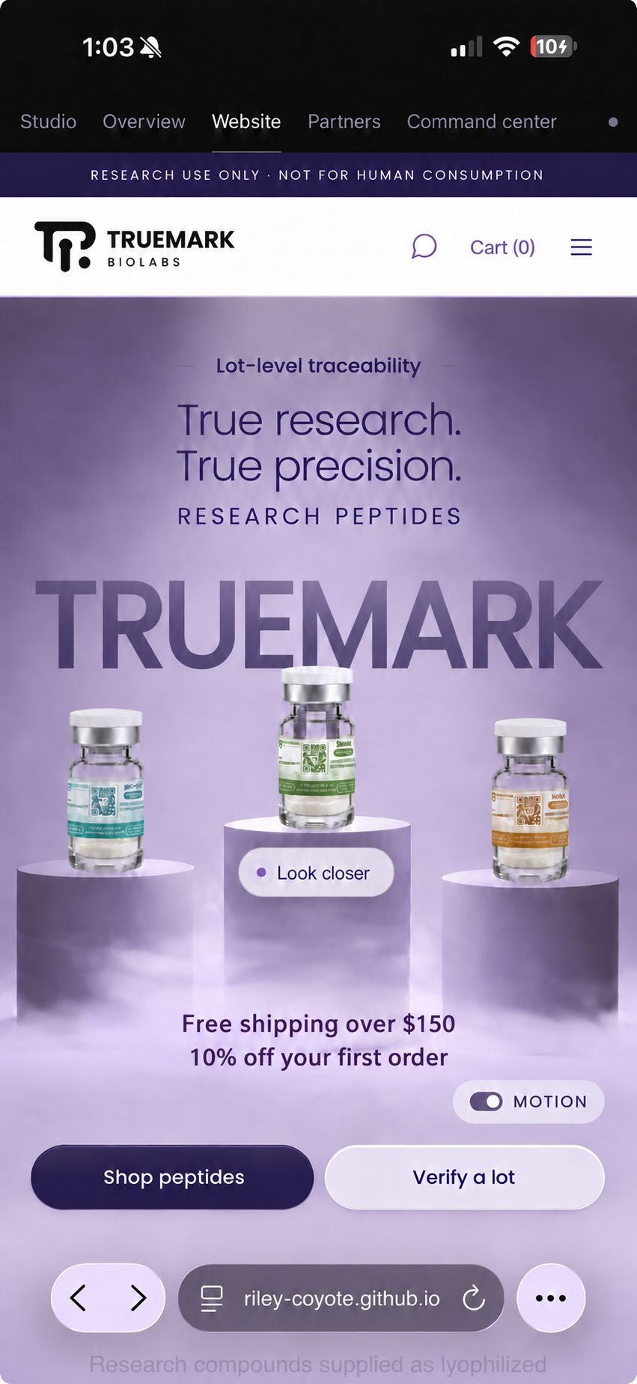
Homepage reference for the brand placement, hero copy, buttons, and promotions below.
- Brand placement: “Verified” was changed to “TRUEMARK.” Position “TRUEMARK” slightly behind the vials, as in the original design, rather than above them.
- Hero copy: retain “RESEARCH PEPTIDES” beneath “True precision.” Change remaining “Research Compounds” wording to “Research Peptides.”
- Buttons: “View catalog” was changed to “Shop Peptides.” Make the “Shop Peptides” button reappear lower down after the “Organized by compound class” section.
- Promotions: clean up the placement of “Free shipping over $150” and “10% off your first order” for the final release.
- Look Closer: skip step 01 and go straight to step 02 so the feature shows its function instead of only zooming in on the vial.
- Compound classes: make the peptides clickable so they lead to the relevant categories. Add continuous carousel scrolling in class order and automatic sliding.
- Fix the desktop compound-class animation. It moves up and down and currently needs an exact scroll position to display and work properly.
- Add animation on mobile when scrolling down from the homepage. Review the spotlight collection carousel: I like it on desktop, but it is not intuitive on mobile.

4 Promotion timing and About page

Delay the first order promotion
Show this popup only after the visitor has scrolled down a little. Agree on the point at which it should appear.
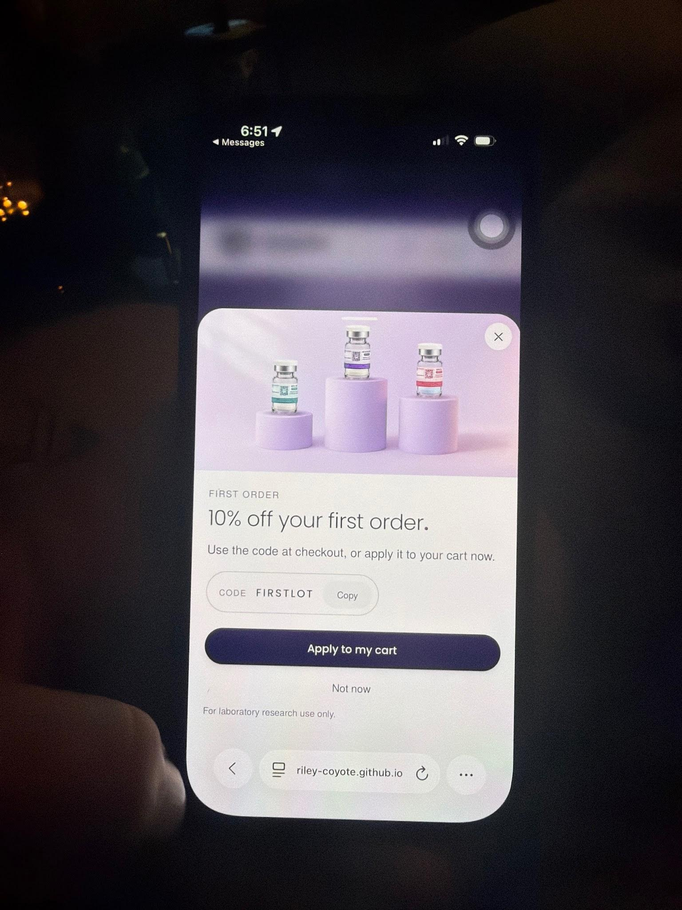
First-order offer popup referenced in the timing request above.

Fix the mobile About page
Resolve the layout and function bugs on the About page. The purity animation overlaps the text on mobile.
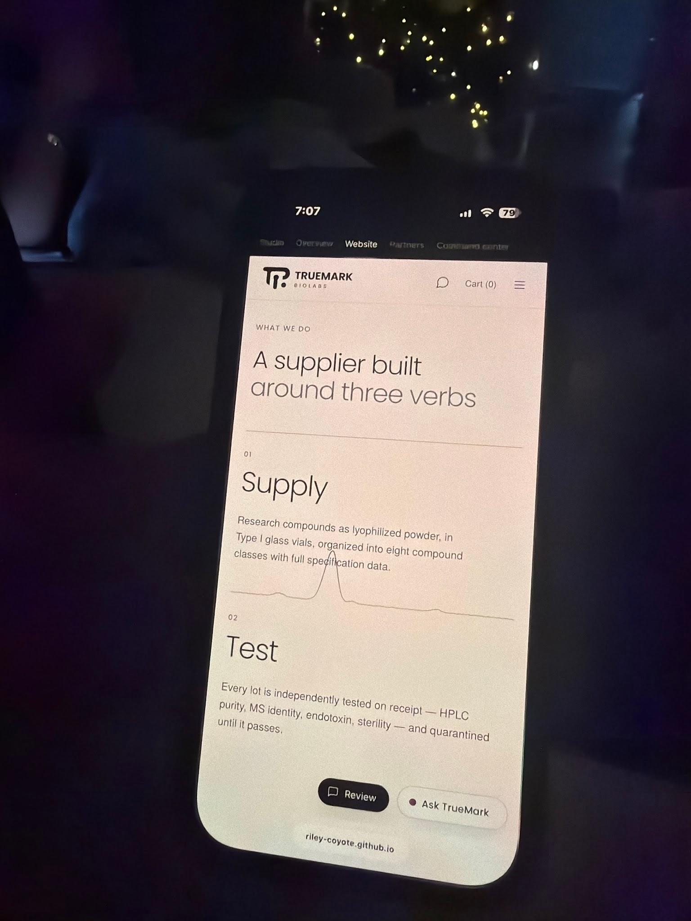
About page reference for the mobile layout and animation issue.

5 Accounts products and checkout

Account creation and first visit
- Discuss the research account application flow in depth and rethink how the overall process should work.
- Review the first-visit research guidelines and verification flow, including how the guidelines open and how the CAPTCHA works.
- Change the account application action from “Apply” to “Create.”

Products and the Verify page
- Show 1-vial, discounted 2-vial, and discounted 3-vial options. Confirm the discount amounts.
- For stacks, show all relevant purity results on the product page and the Verify page. Remove the limitation that prevents all purity percentages from reaching the main site.
- Change the GLP-1 names. Confirm the exact replacement names before making the edits.
- Revisit the Verify page animation. I preferred the original animation, but want it to fit the current visual style.

Cart and checkout
- Add shipping insurance to the cart, enabled by default with an option for the customer to turn it off.
- Use the same add-to-cart popup on desktop as on mobile.
- Improve the cart progress bar using the end-to-end lot explanation as the visual reference.
- Clean up the cart and add-to-cart animations on mobile and desktop so the movement, timing, and confirmation feel polished and consistent.

Rewards and thresholds
- Clean up the cart popup animation on mobile and desktop and make it mimic the homepage slider. It should show progress toward free Bac Water and free shipping at $200. Confirm the free Bac Water threshold and update any older $150 free-shipping language so the site is consistent.
- Integrate the loyalty points system and agree on the earning and redemption rules.

Key decisions for this section
Agree on the account and first-visit flow, GLP-1 replacement names, vial discounts, reward thresholds, and the Verify animation reference.

6 Background and scroll bugs

Refresh flicker and moving background light
Fix the background changing or jumping from dark to light on initial refresh and while scrolling. The screenshots below show the background states referenced in the original notes.
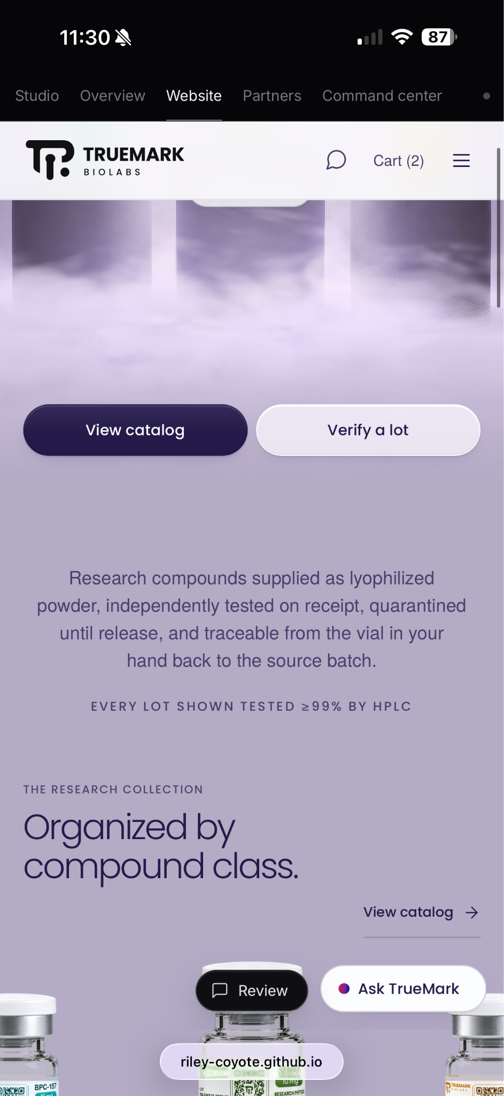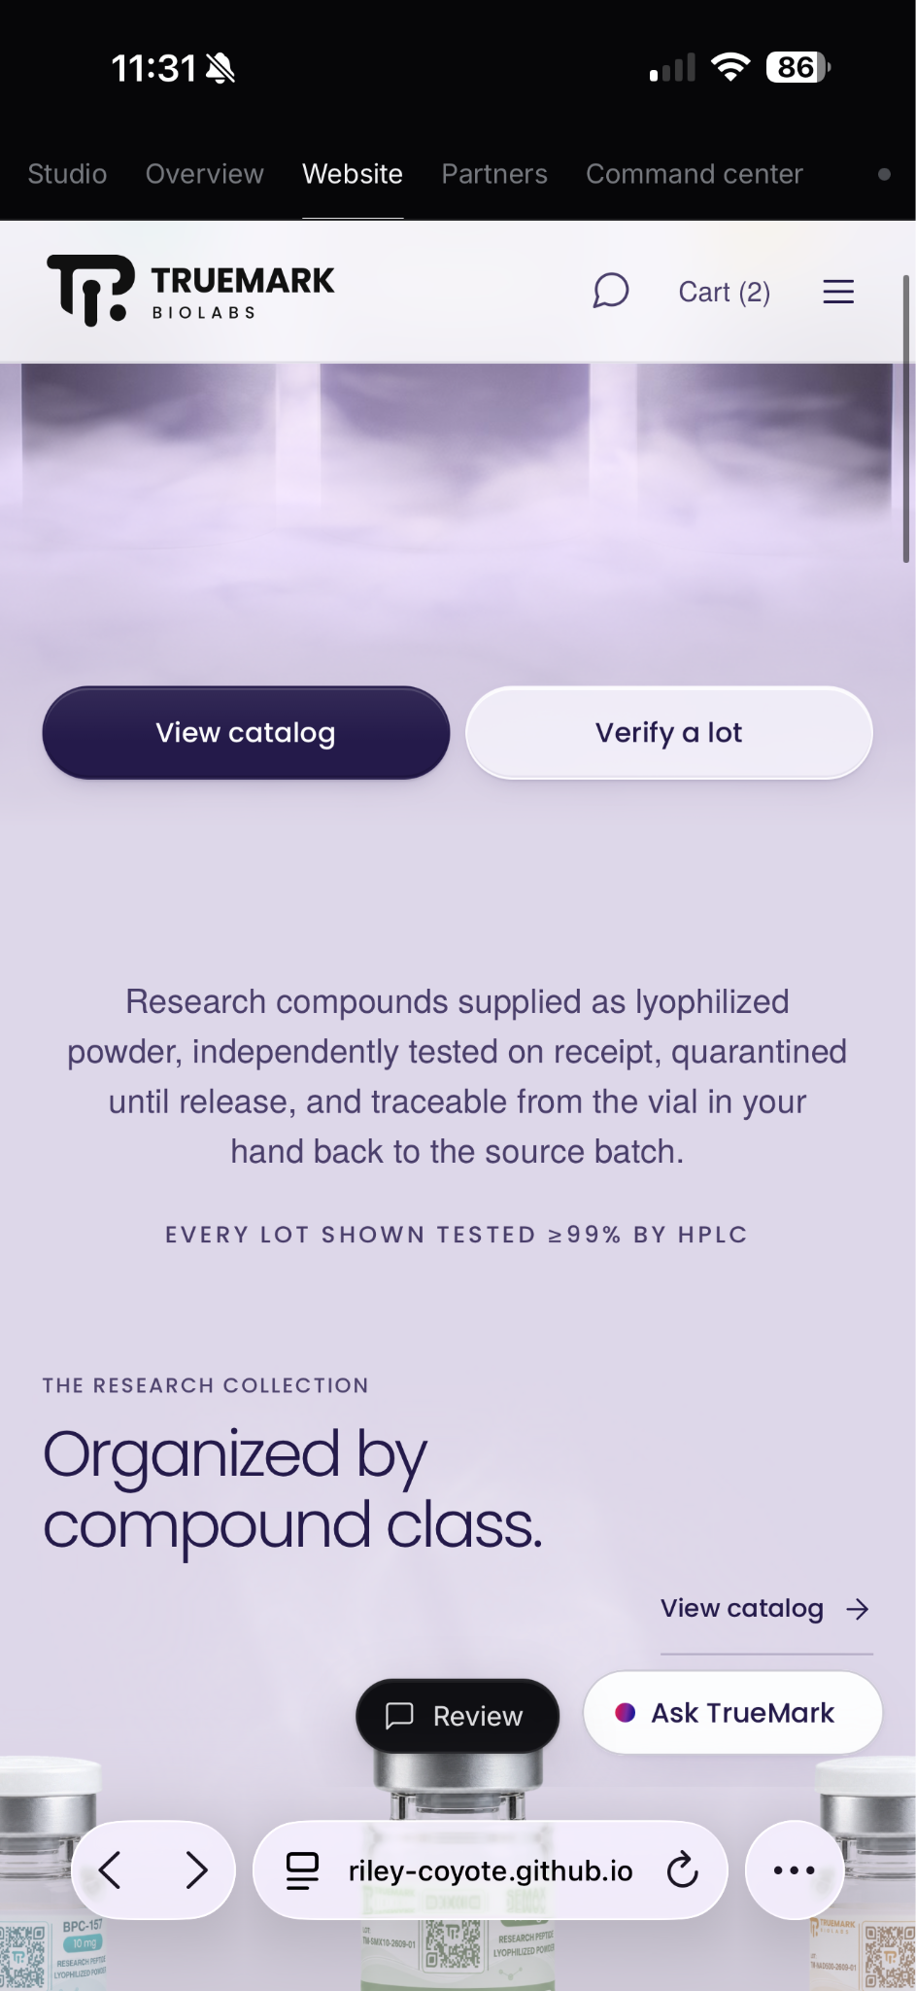
Two screenshots of the homepage background and compound-class section.
- Make the background hue and light effect move smoothly during scrolling, as it does on desktop. It currently jumps after scrolling stops.
- Check the transition into the compound-class section alongside the desktop animation fix on page 3.

Return to the homepage
The homepage loads correctly on the first visit. After opening another page, returning home through the navigation logo or the browser Back button produces a glitchy load. Reproduce and fix both return paths.

7 Spacing and remaining questions

Remove unexpected empty space
Fix empty-space glitches across pages, including the Coenzymes & cofactors section. Use the screenshot below as the layout reference.
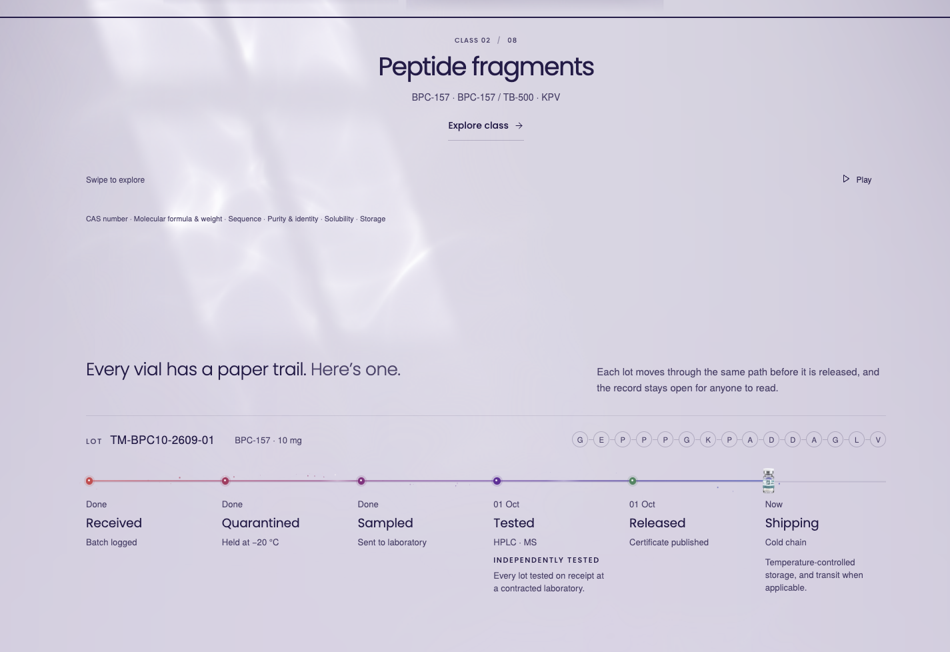
Original spacing reference showing a large gap above the lot traceability explanation.

HP Envy on Windows
On my mom’s HP Envy, the site shows the desktop layout and navigation, but behaves as though it loaded the mobile version: no animation on scroll, a carousel that is not continuous, and a glitchy background. Investigate why these mobile-style issues appear in the desktop view. Confirm the browser, affected pages, and steps to reproduce.

Questions to settle with Riley
- Which parts of the backend and integrations can we demonstrate working now, and which still need to be built or connected?
- How will the customer agent learn through the TrueMark brain and give more thoughtful help? Which previously discussed partner actions will it perform, and how does the existing personal agent connect?
- What website URL and remaining setup are needed for payment processing?
- What exact settings should we use for shipping statuses, large-order reviews, discounts, rewards, and profit calculations?
- Which fixes are required for launch, who owns each one, and when will we review the completed work?

